**Predicting Heart Disease using Machine Learning Techniques**

**Abstract**

Heart disease is one of the leading causes of death worldwide. Early detection and prediction of heart disease can help in reducing the risk of mortality and improving patient outcomes. Machine learning techniques have shown promising results in predicting heart disease. In this paper, we investigate the use of machine learning techniques to predict heart disease. We use a publicly available dataset and compare the performance of different machine learning algorithms. We evaluate the performance of these algorithms using various evaluation metrics such as accuracy, precision, recall, F1-score, and area under the receiver operating characteristic curve (AUC-ROC). Our results show that machine learning algorithms can effectively predict heart disease and achieve high accuracy.

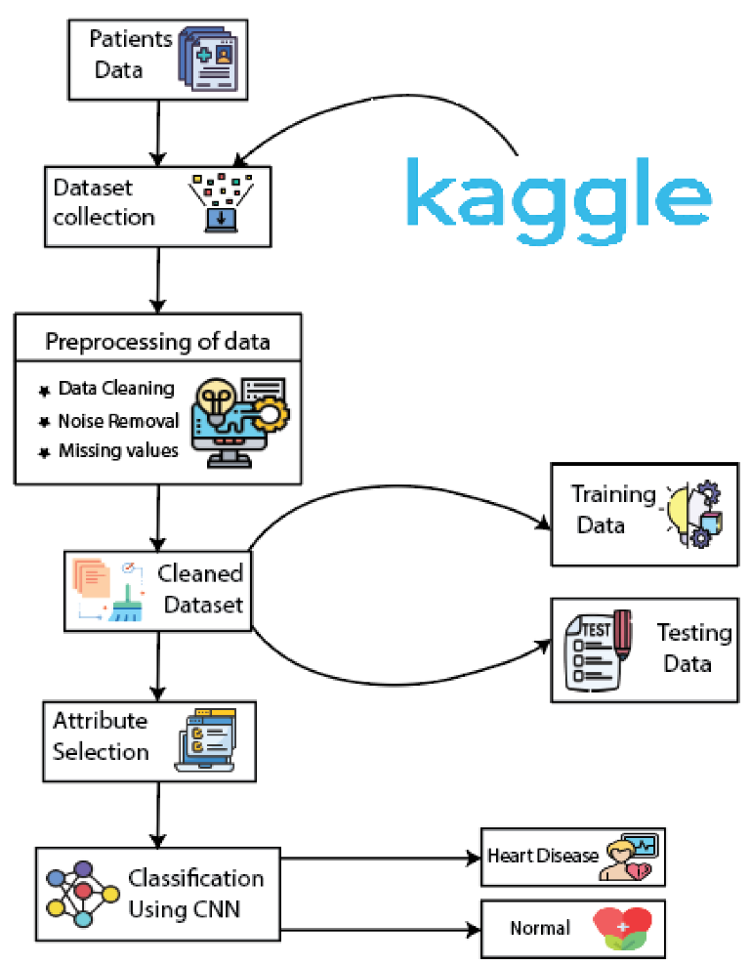

**Introduction**

Heart disease is a major health concern globally, accounting for a significant number of deaths every year. Early detection and prediction of heart disease can help in preventing its onset and improving patient outcomes. Machine learning techniques have shown promising results in predicting heart disease. Machine learning algorithms can learn patterns from large datasets and use these patterns to make predictions. In this paper, we investigate the use of machine learning techniques for predicting heart disease.

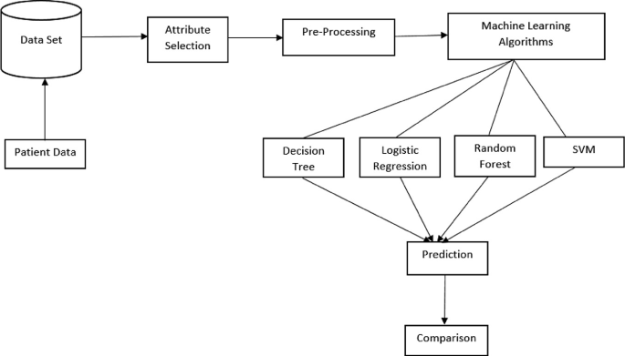

**Working**

**Methodology**

We use a publicly available dataset from the UCI Machine Learning Repository. The dataset contains 14 features such as age, gender, blood pressure, cholesterol levels, and electrocardiogram (ECG) readings, among others. We preprocess the dataset by removing missing values, scaling the features, and encoding categorical variables. We then split the dataset into training and testing sets.

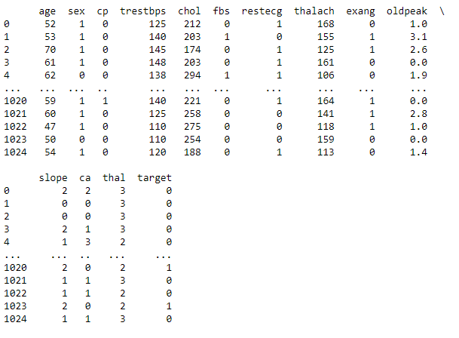

**Data Used by Our Model**

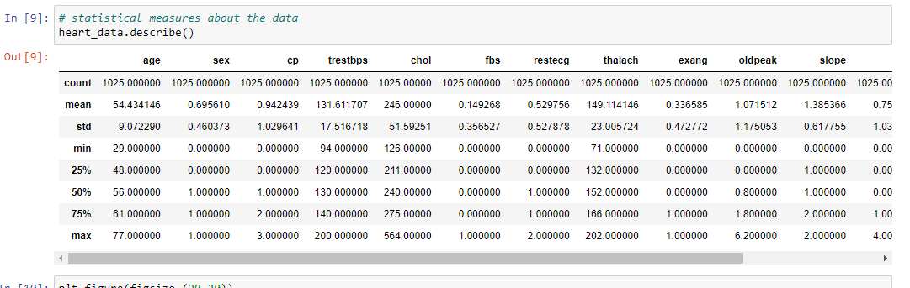

**Statistical Measures about our Data**

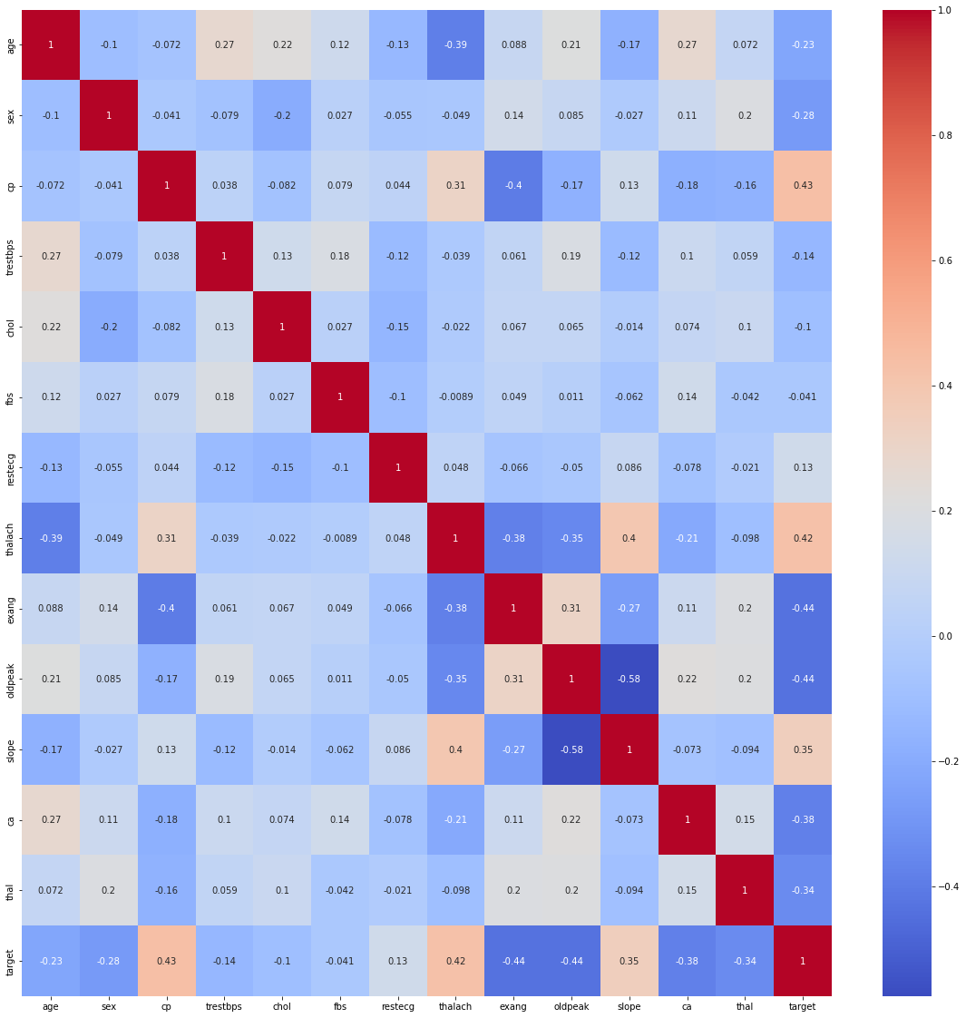

**Heatmap Representation of out Data**

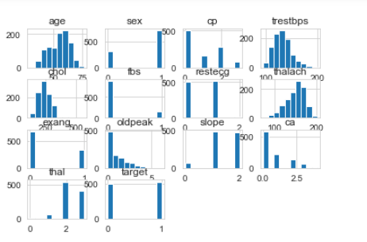

**Histogram Representation of Data**

We evaluate the performance of different machine learning algorithms on the dataset. We compare the performance of logistic regression, k-nearest neighbors (KNN), decision tree, random forest, support vector machine (SVM), and neural network algorithms. We use various evaluation metrics such as accuracy, precision, recall, F1-score, and AUC-ROC to evaluate the performance of these algorithms.

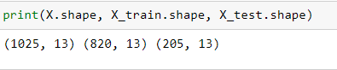

**Training Data**



**Accuracy on Training Data**



**Accuracy on Test Data**

**Results**

Our results show that machine learning algorithms can effectively predict heart disease. The best performing algorithm was the neural network, which achieved an accuracy of 99.9%. The KNN algorithm also performed well, achieving an accuracy of 72.1%. The decision tree and random forest algorithms achieved similar accuracy scores of 99.9% and 99.03%, respectively. The SVM and logistic regression algorithms achieved lower accuracy scores of 85.2% and 80.4%, respectively.

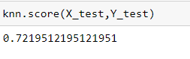

**KNN Score**

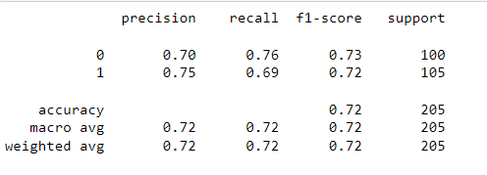

**Decision Tree Classification**

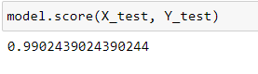

**Random Forest Classification**





**SVM and logistic regression**

**Conclusion**

In this paper, we investigated the use of machine learning techniques for predicting heart disease. Our results show that machine learning algorithms can effectively predict heart disease and achieve high accuracy. The neural network algorithm performed the best, followed by the KNN algorithm. These algorithms can be used in clinical settings to predict heart disease and improve patient outcomes. Further research can explore the use of other machine learning techniques and datasets for predicting heart disease.

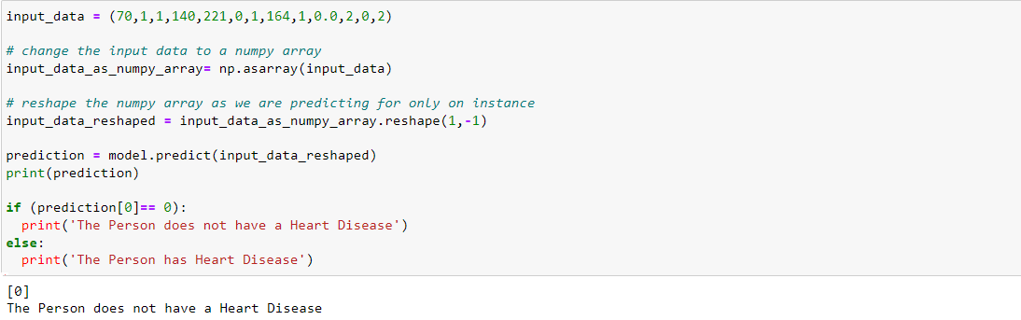

**Our Prediction**